Mat Hanson

11575596 | mathanson87@gmail.com

Assessment 3 – Research Project Design

itc542 – internetworking with tcp/ip

# Executive Summary

The first decision in the process of designing this internetwork was to decide on an appropriate addressing scheme for each of the 3 separate networks. The decision to use a /24 addressing scheme was made on the basis of keeping addressing simple and easy to maintain.

The two servers are Windows Server 2012 R2, the three client PCs are Windows 10, the two routers are Cisco C2691, and the two switches are generic unmanaged Ethernet switches. The gateway interfaces were configured as .254 addresses in order to start the available addresses from the beginning of each subnet, for consistency sake.

The rest of this report will describe in detail how this configuration was achieved in a way that the routers are properly handling routing of packets and the servers configured correctly as requested in the assessment outline. Please refer to Fig.1 below for the Network Topology Design.

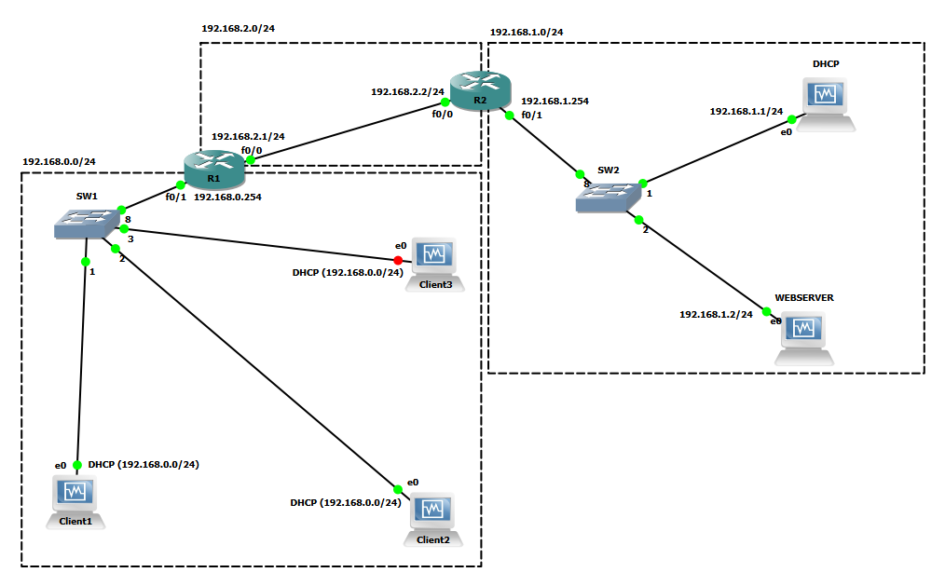Fig. 1. Network Topology Design

**Part 1**

1. Configuration of interfaces
   1. Routers -  
      **R1**
      1. Configure 0/0 interface as 192.168.2.1 using “ip address 192.168.2.1 255.255.255.0”.
      2. Set description as connection to R2 using “desc Connection to R2”.
      3. Configure 0/1 interface as 192.168.0.254 using “ip address 192.168.0.254 255.255.255.0”.
      4. Set description as connection to SW1 using “desc Connection to SW1”.
      5. Run “show ip interface brief” to make sure everything is correct. I realised that I forgot to bring the interfaces up.
      6. Go back to configure each interface and run “no shutdown” command to bring both interfaces up.
      7. Run “show ip interface brief” again to make sure everything is correct. Everything looks good.  
         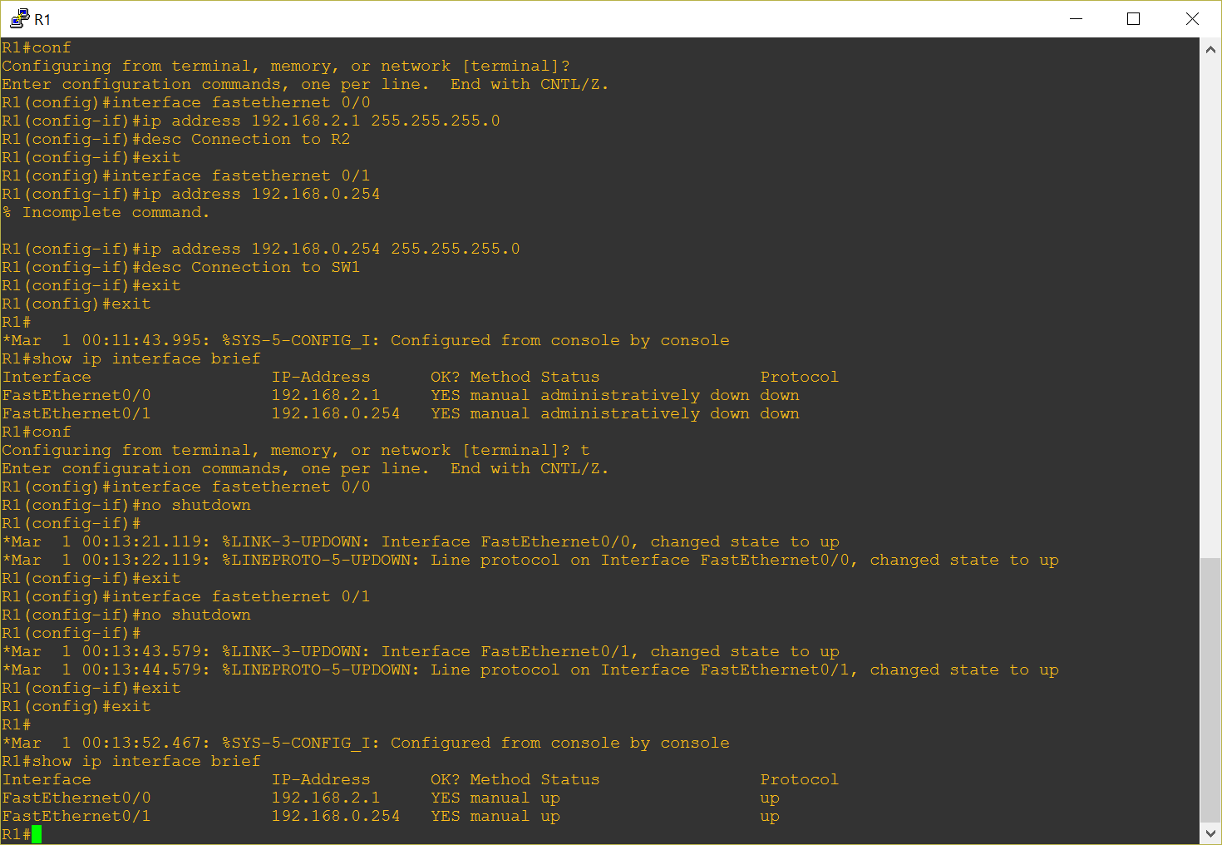

**R2**

1. Configure 0/0 interface as 192.168.2.2 using “ip address 192.168.2.2 255.255.255.0”.
2. Set description as connection to R1 using “desc Connection to R1”.
3. Run “no shutdown” command to bring interface up.
4. Configure 0/1 interface as 192.168.1.254 using “ip address 192.168.1.254 255.255.255.0”.
5. Set description as connection to SW2 using “desc Connection to SW2”.
6. Run “no shutdown” command to bring interface up.
7. Run “show ip interface brief” to make sure everything is correct. Everything looks good.  
   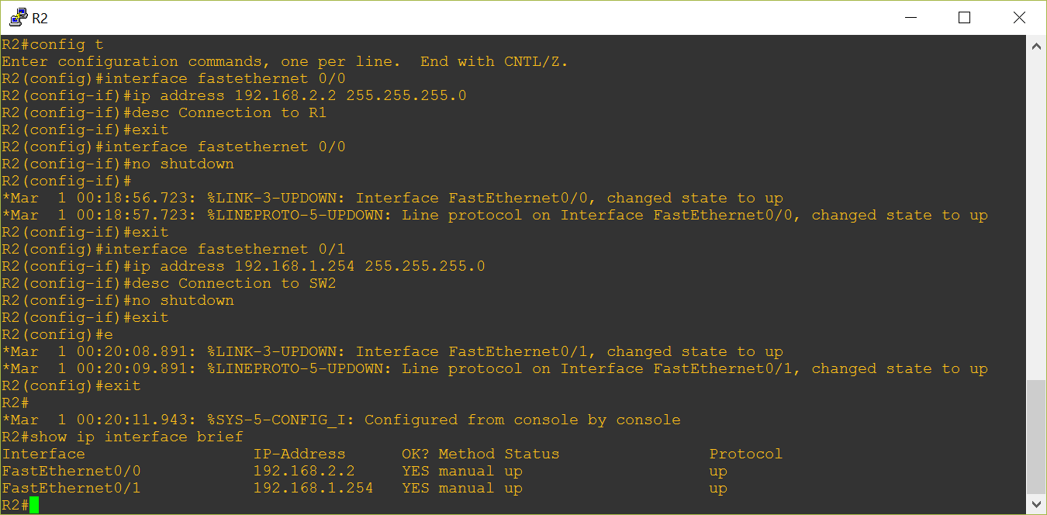
   1. DHCP Server -   
      Manually configure interface as 192.168.1.1, the default gateway to 192.168.1.254(R2) and the DNS server to 192.168.1.1.  
      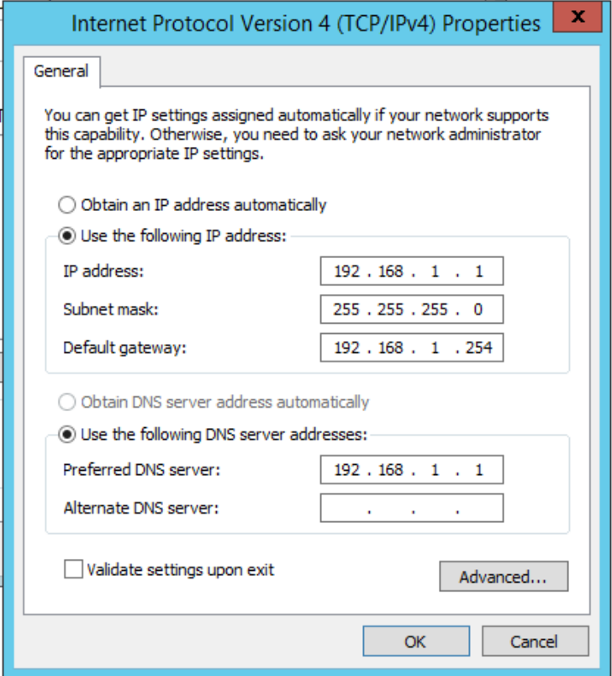

Web Server –

Manually configure interface as 192.168.1.2, the default gateway to 192.168.1.254(R2) and the DNS server to 192.168.1.1.

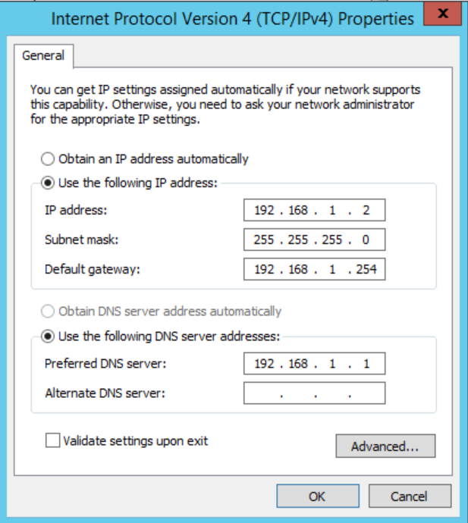

* 1. PCs -  
     Leave the PCs set to DHCP by default. The DHCP server will manage the IP addresses of these clients.  
     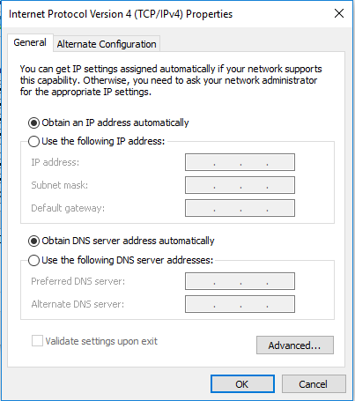

1. IP Routing
   1. **R1**
      1. Configure a static route on R1 so that it is aware of the 192.168.1.0 network and that it can communicate with the network via 192.168.2.2, which is an interface on R2.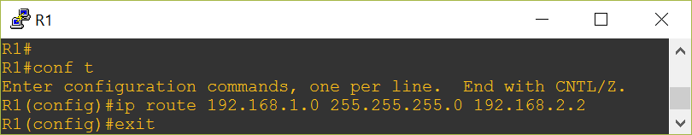
      2. Turn on IP routing.

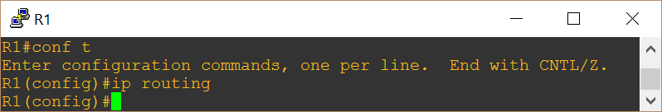

* + 1. Show the routing table to make sure that the routing is correct.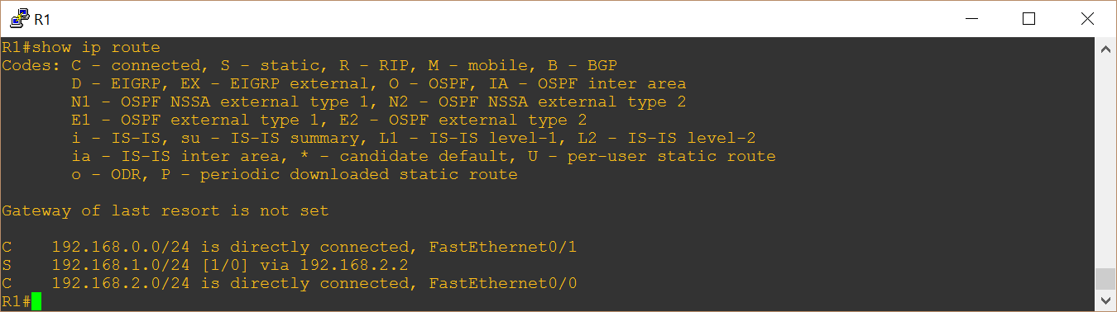
  1. **R2**
     1. Configure a static route on R2 so that it is aware of the 192.168.0.0 network and that it can communicate with the network via 192.168.2.1, which is an interface on R1.  
        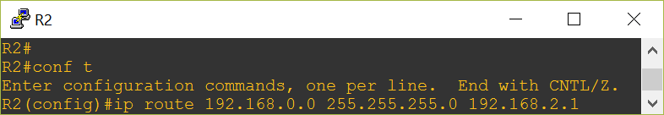
     2. Turn on IP routing.  
        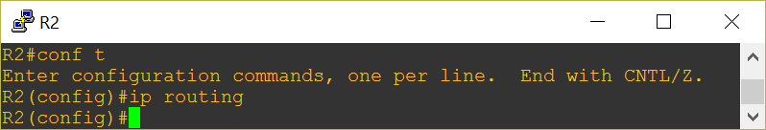
     3. Show the routing table to make sure that the routing is correct.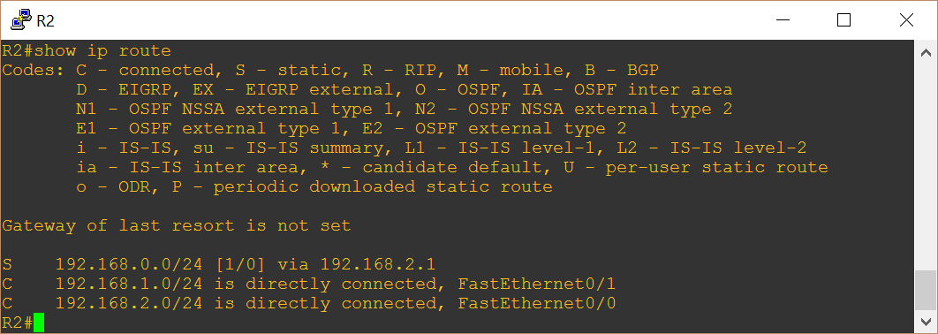
  2. DHCP Relay  
     Since the client PCs are on a separate network to the DHCP server, a DHCP Relay is required on the gateway closest to the client PCs so that the DHCP Discover packets are routed to the DHCP server. We are going to configure a DHCP relay on R1 as that is the closest gateway to the clients.   
     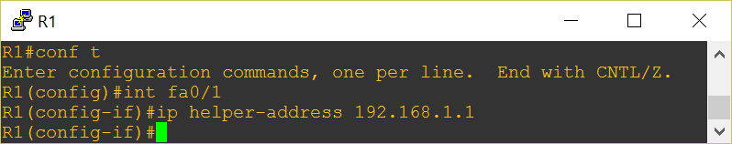

With the relay in place, when the client sends a DHCP discover broadcast packet, the router will convert the broadcast packet into a unicast packet and send it to 192.168.1.1. Since R1 knows (from its routing table) that it can connect to 192.168.1.0 via 192.168.2.2, the packet will be routed to 192.168.2.2(R2), which will handle the routing to 192.168.1.1 from there.

1. Show network connectivity from the Client PC.
   1. First, ran ipconfig to get the local IP address.
   2. Ping local address – 192.168.0.2
   3. Ping local router gateway interface – 192.168.0.254
   4. Ping remote router interface – 192.168.2.2
   5. Ping server – 192.168.1.1  
      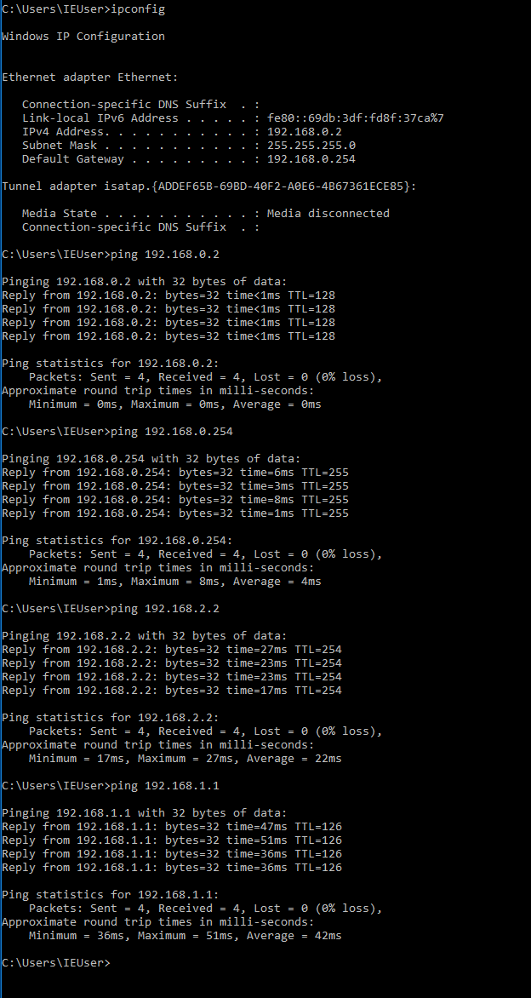
2. From the client PC, I ran a traceroute command to the server (192.168.1.1). The packet went through the local router gateway (192.168.0.254 – int0/1 on R1) to the remote router interface of R2 (int0/0 – 192.168.2.2), which then routed the packet to the server – 192.168.1.1.  
   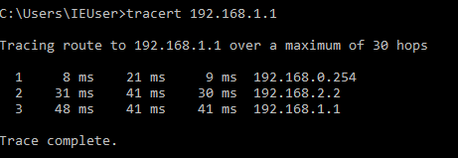

**Part 2**

1. Configuring DHCP Server –
2. Under Server Manager>Dashboard, click on “Add roles and features”.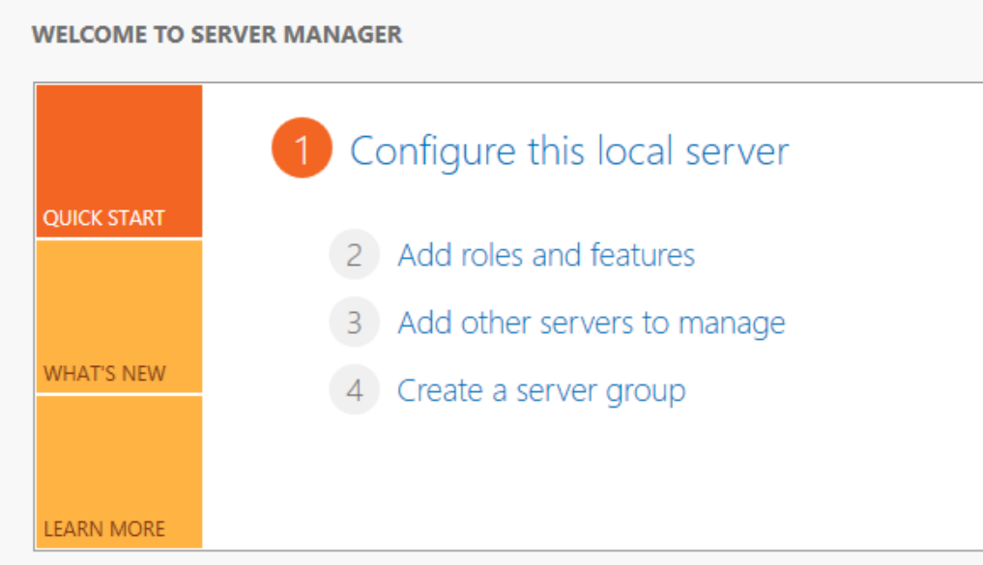
3. The Add Roles and Features Wizard will appear, click next until you get to the Server Roles section.  
   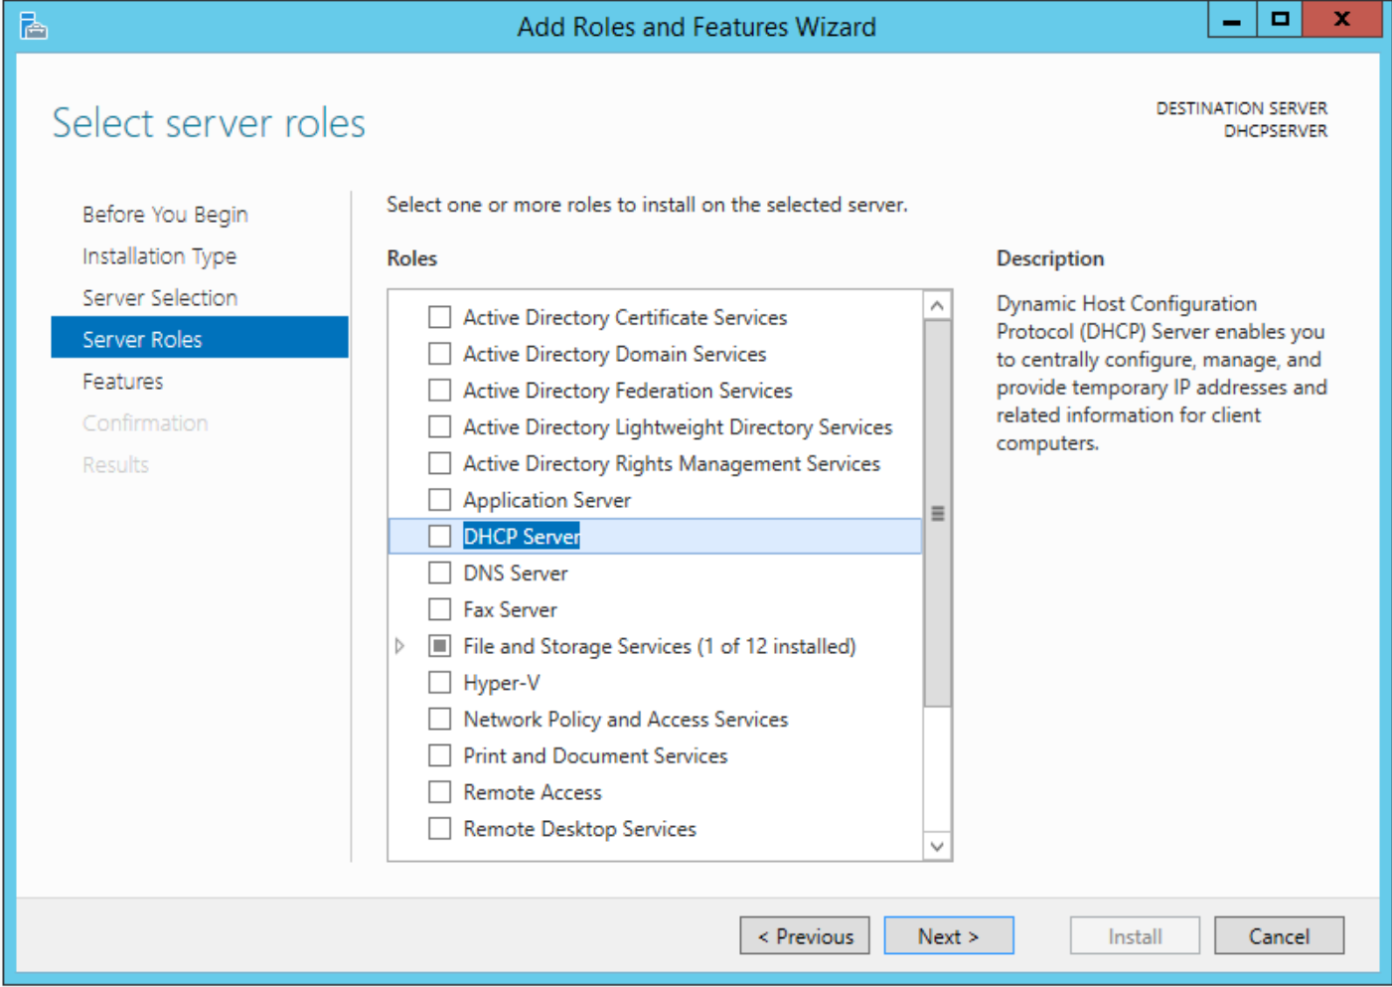
4. Select DHCP Server. A prompt will appear asking you to confirm, click the Add Features button and this will take you back to the Wizard. Click Next, and then continue to click next on the following sections until you get to the Confirmation tab.
5. Check the “restart the destination server automatically if required” checkbox and click Install.  
   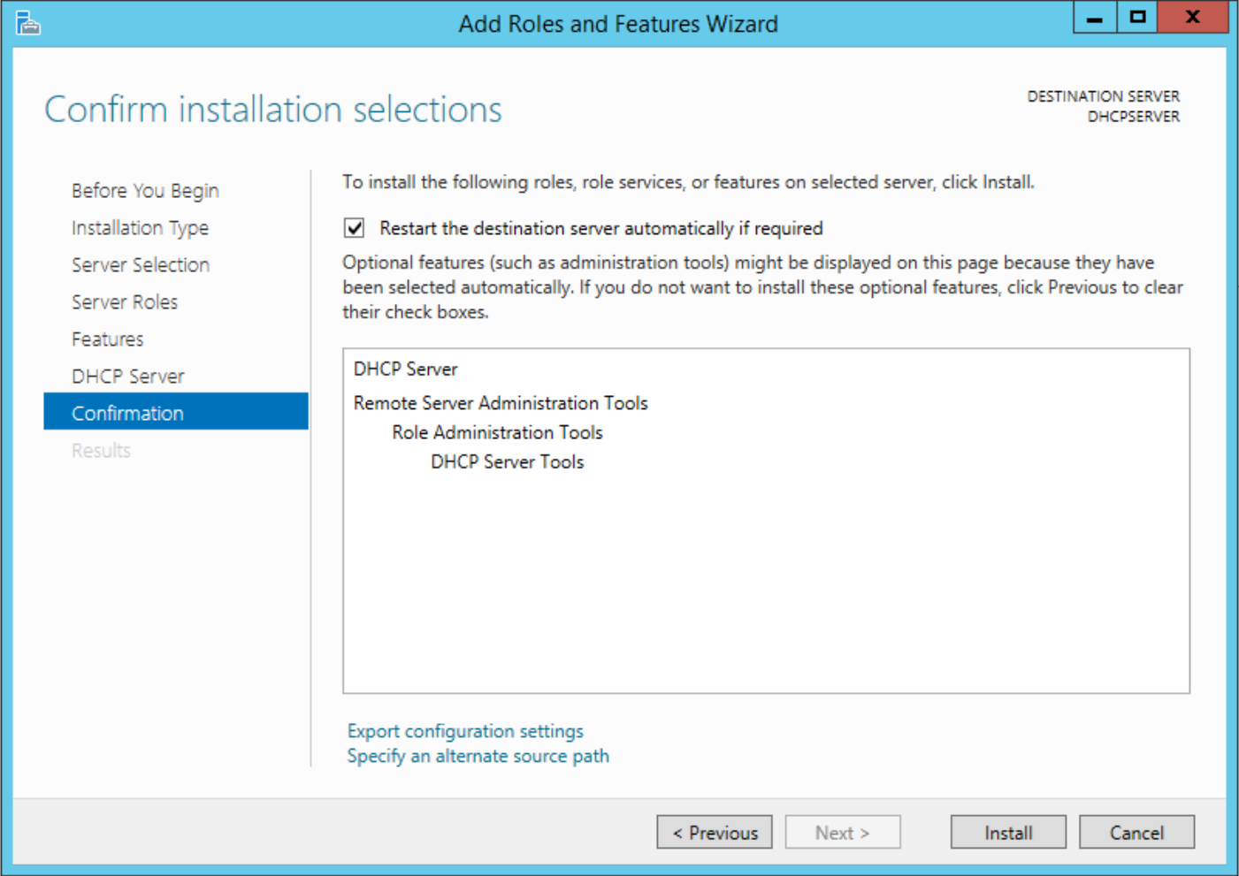
6. Once the install has completed, click on Close.
7. Click on notifications on the dashboard and click on complete DHCP Configuration.

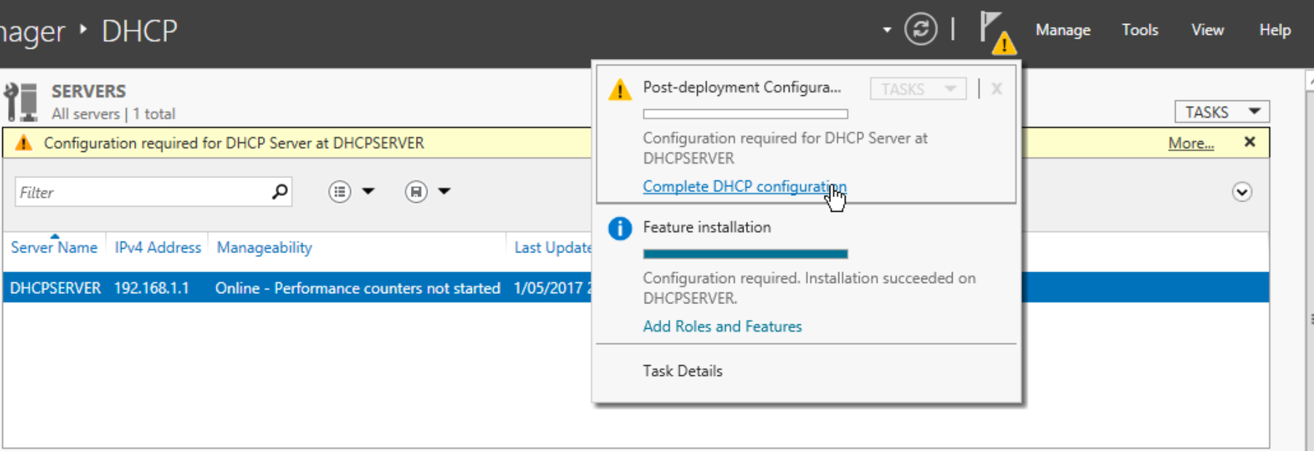

From the Dashboard, click on Tools>DHCP.  
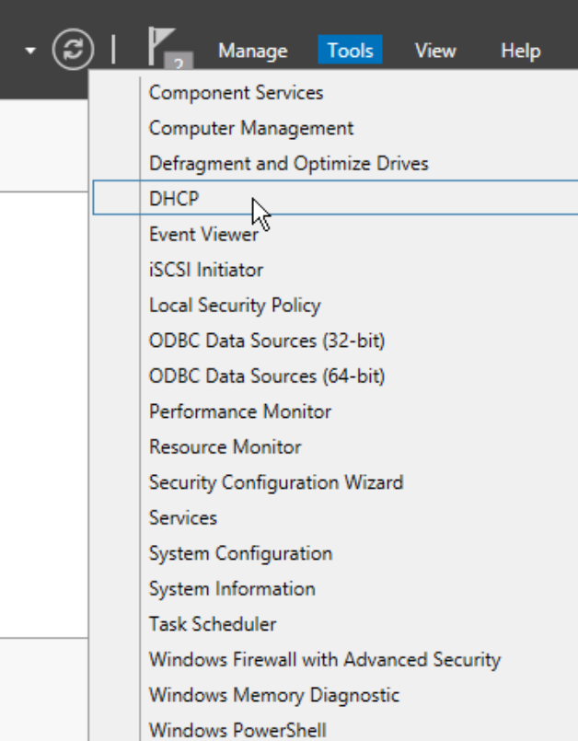

1. From the DHCP Manager, expand dhcpserver and then IPv4. Right click on IPv4 and select New Scope.  
   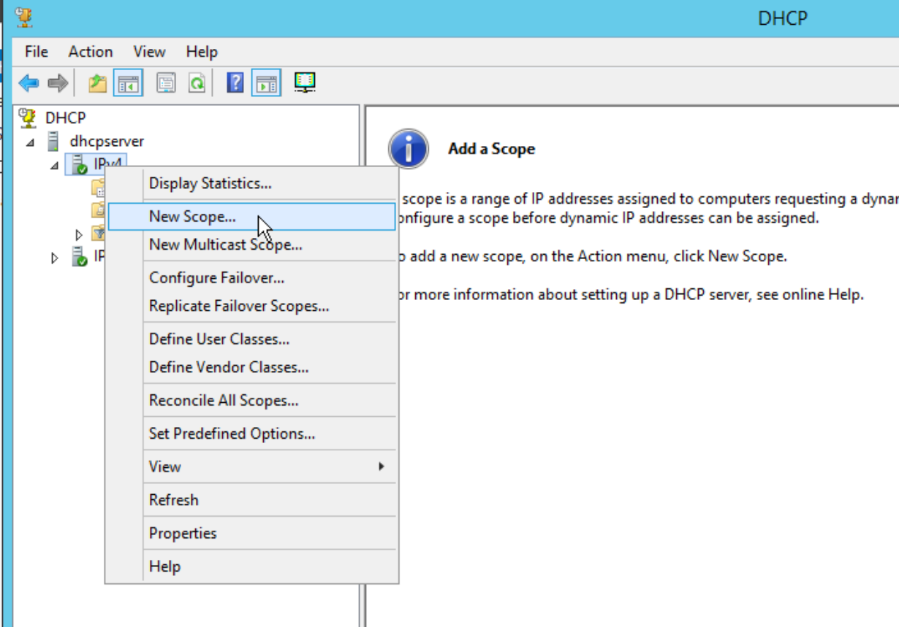
2. Click Next, and then enter the name of the scope that you would like to create. In this instance, we are creating a scope named Clients. Click Next.  
   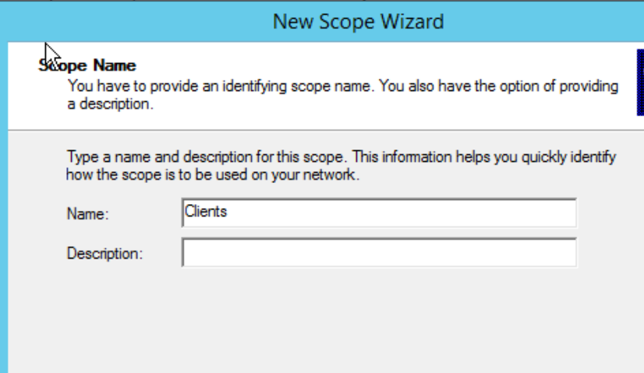
3. Enter the start and end IP addresses of the scope. In this instance, we are starting on 192.168.0.1 and ending on 192.168.0.100. Make sure that the subnet mask is correct. Click next.  
   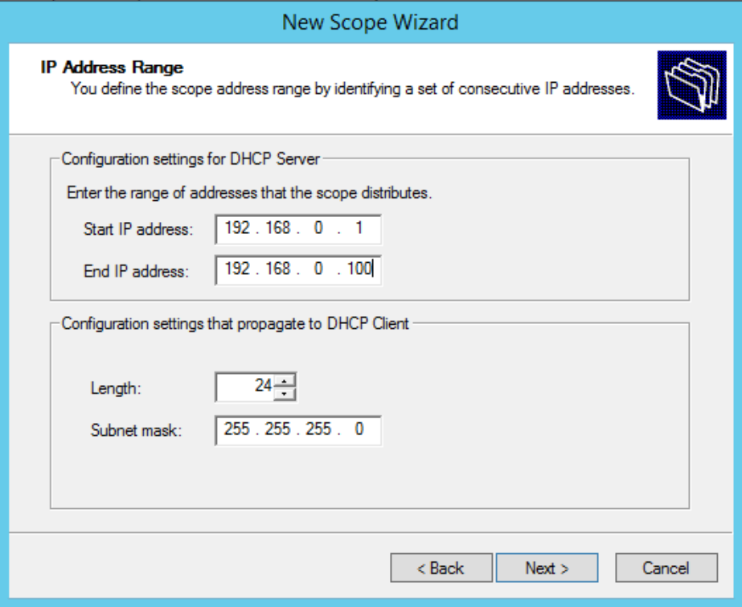
4. Click next on exclusions/delays as we are not using any in this instance.
5. Leave the default lease time at 8 days and click next.
6. In the router section, we want to add the router that is the default gateway for the clients, which is R1. R1’s interface on the 192.168.0.0 network is 192.168.0.254. Enter that IP address in the field, click Add and then click Next.  
   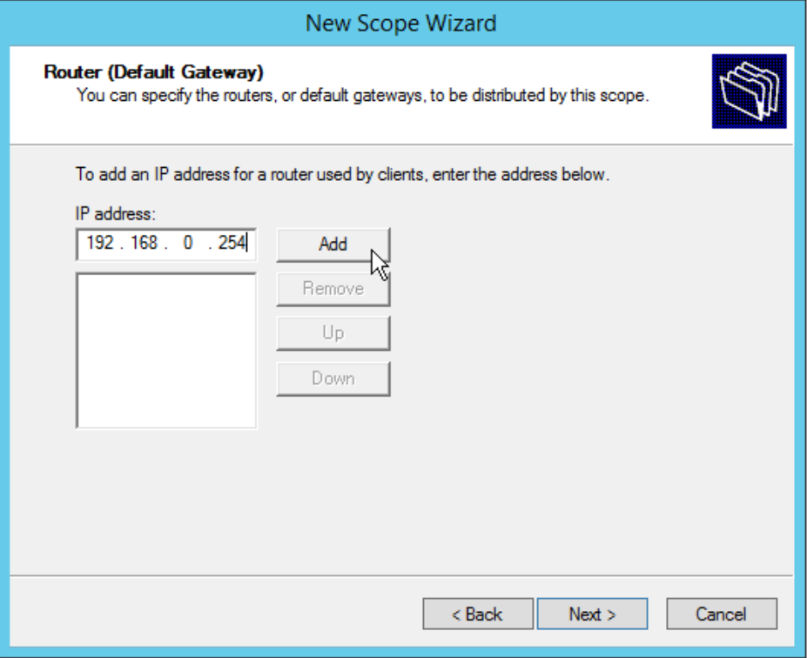
7. The next window is to setup Domain Name and DNS. Since we aren’t using a domain, we skip that setting. Under DNS, we are using this server as a DNS server, type in dhcpserver in Server name and click resolve, which will resolve 192.168.1.1. Click Add which will validate the address. After validation is complete, click Next.  
   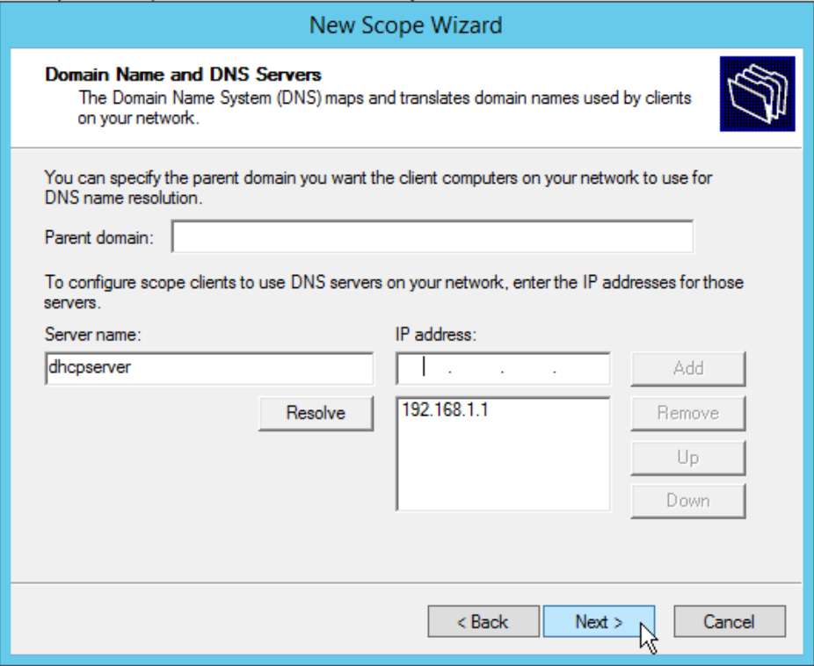
8. Click Next on all the following screens and then click Finish.
9. Show that client PC is able to receive an IP address via DHCP –  
   On the client PC, I ran “ipconfig /all” to show the configuration.  
   DHCP Enabled – Yes  
   IPv4 Address – 192.168.0.2  
   Subnet Mask – 255.255.255.0  
   Default Gateway – 192.168.0.254  
   DHCP Server – 192.168.1.1  
   DNS Server – 192.168.1.1

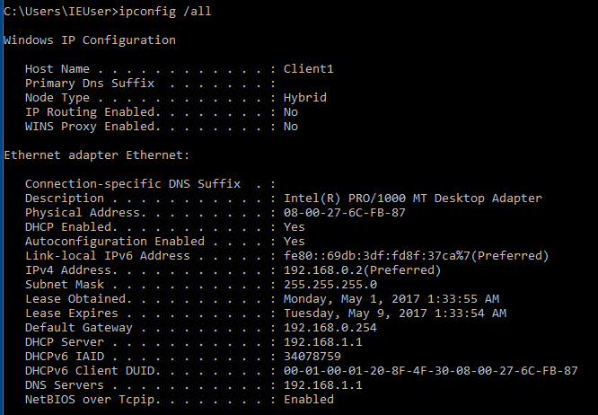

1. Configure WEB Server –
2. Under Server Manager>Dashboard, click on “Add roles and features”.
3. The Add Roles and Features Wizard will appear, click next until you get to the Server Roles section.  
   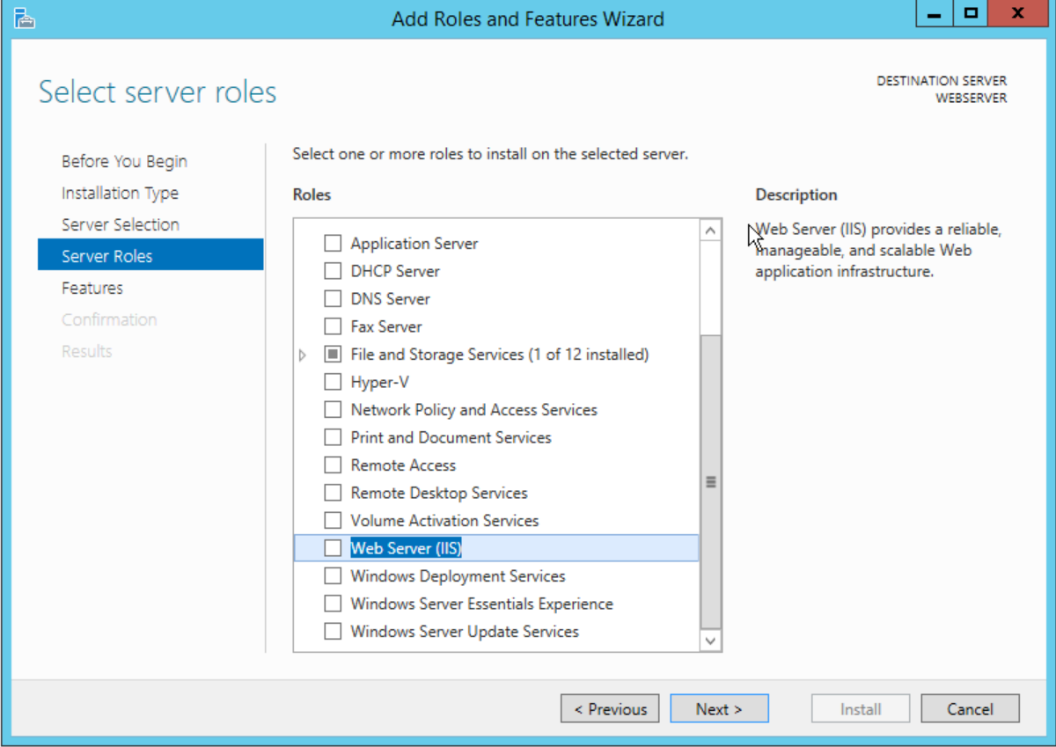
4. Select Web Server(IIS). A prompt will appear asking you to confirm, click the Add Features button and this will take you back to the Wizard. Click Next, and then continue to click next on the following sections until you get to the Confirmation tab.
5. Check the “restart the destination server automatically if required” checkbox and click Install.  
   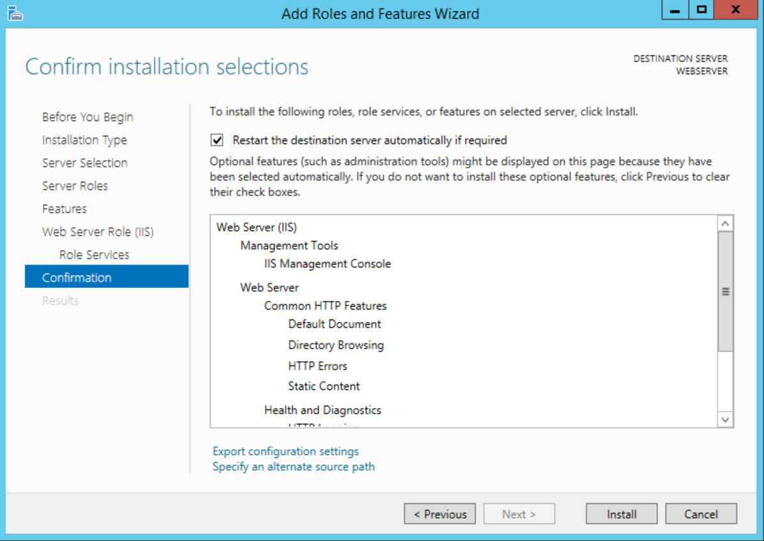
6. Once the install has completed, click on Close.
7. On the Server Manager Dashboard, go to the Tools menu and click on Internet Information Services (IIS) Manager.  
   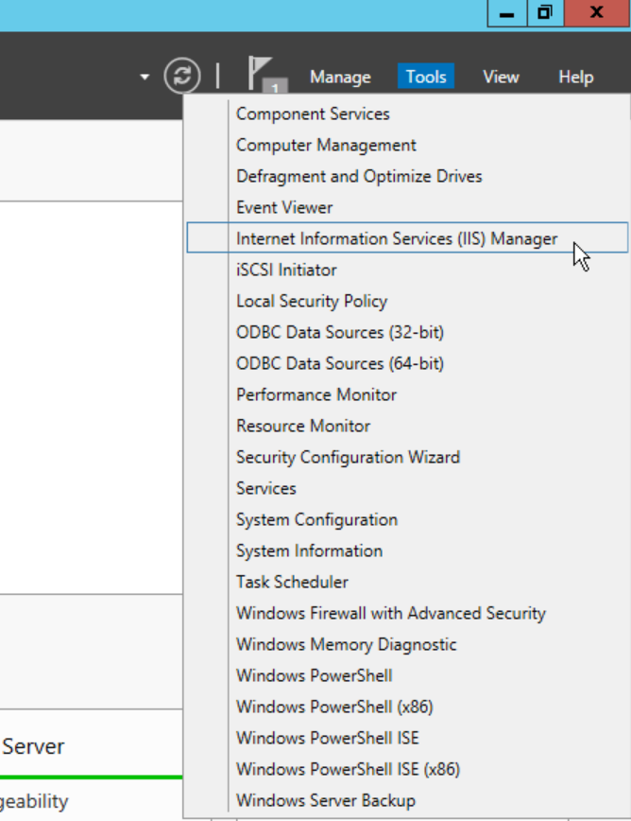
8. Within the Connections pane of the IIS Manager, expand WEBSERVER and right-click on Sites. Click on Add Website.  
   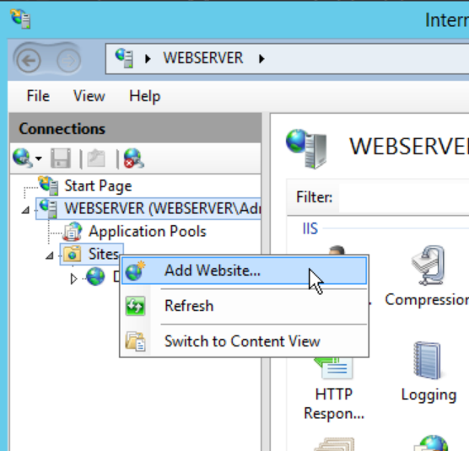
9. The Add Website window will appear. Enter details for Site name, Content Directory, and Hose name as below. Click OK.  
   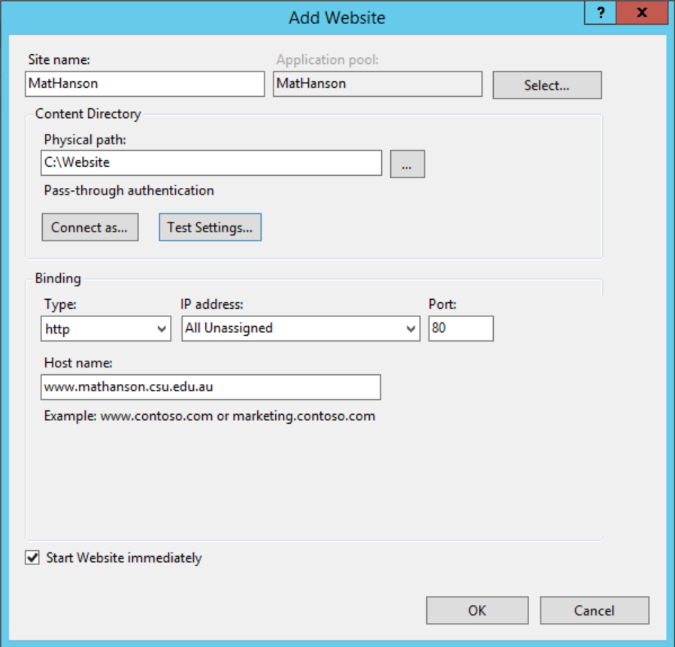
10. Configure DNS
    * Under Server Manager>Dashboard, click on “Add roles and features”.  
      
    * The Add Roles and Features Wizard will appear, click next until you get to the Server Roles section.
    * Select DNS Server. A prompt will appear asking you to confirm, click the Add Features button and this will take you back to the Wizard. Click Next, and then continue to click next on the following sections until you get to the Confirmation tab.
    * Click Install.  
      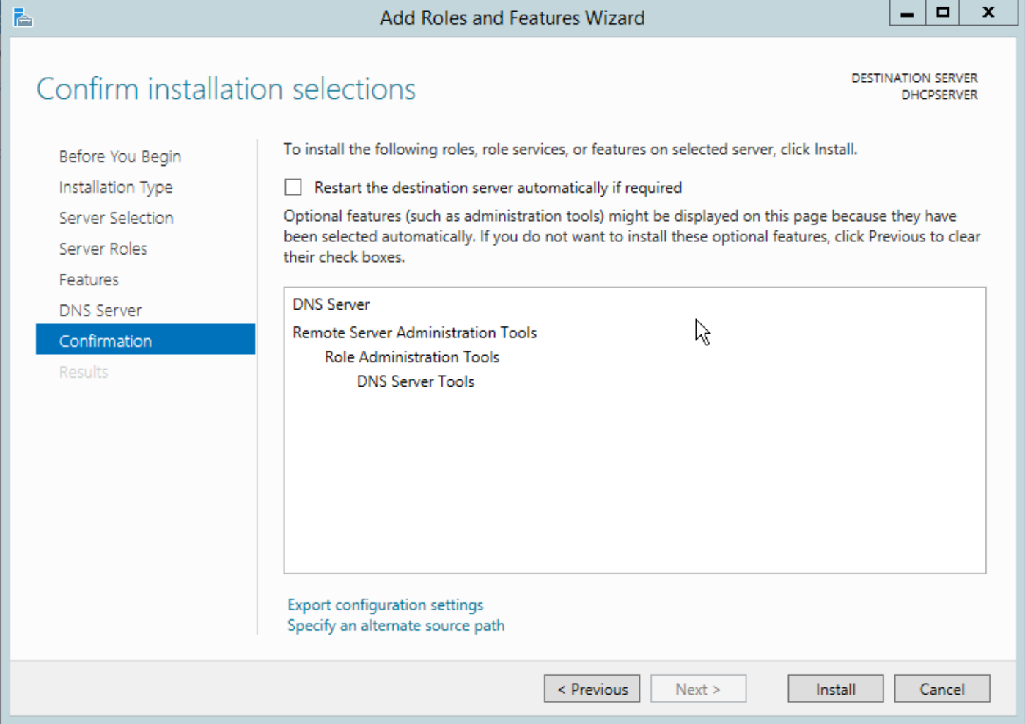
    * Once the install is complete, click on Close.
    * On the Server Manager Dashboard, go to the Tools menu and click on DNS.  
      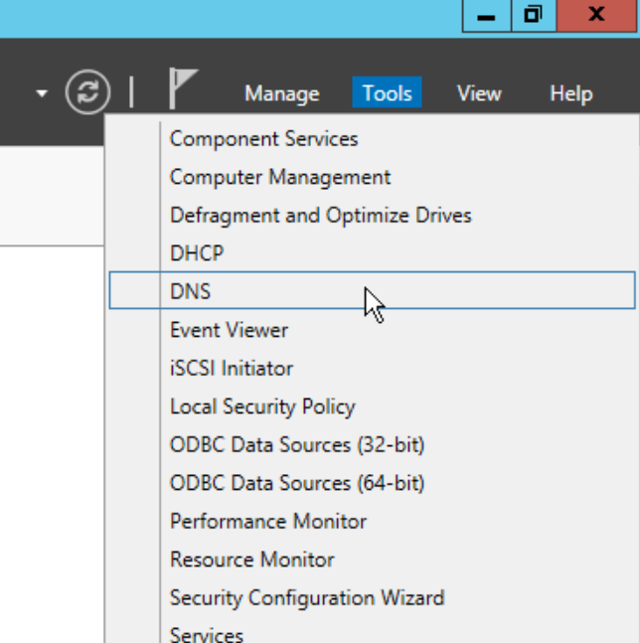
    * Right-click on DHCPSERVER and click on Configure a DNS Server…  
      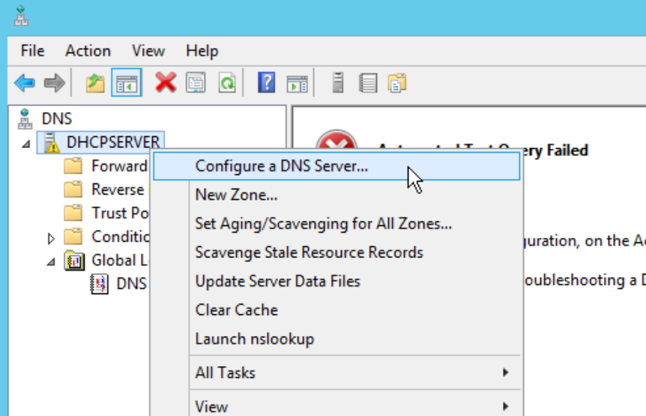
    * Click Next and then choose “Create forward and reverse lookup zones”. Click Next.  
      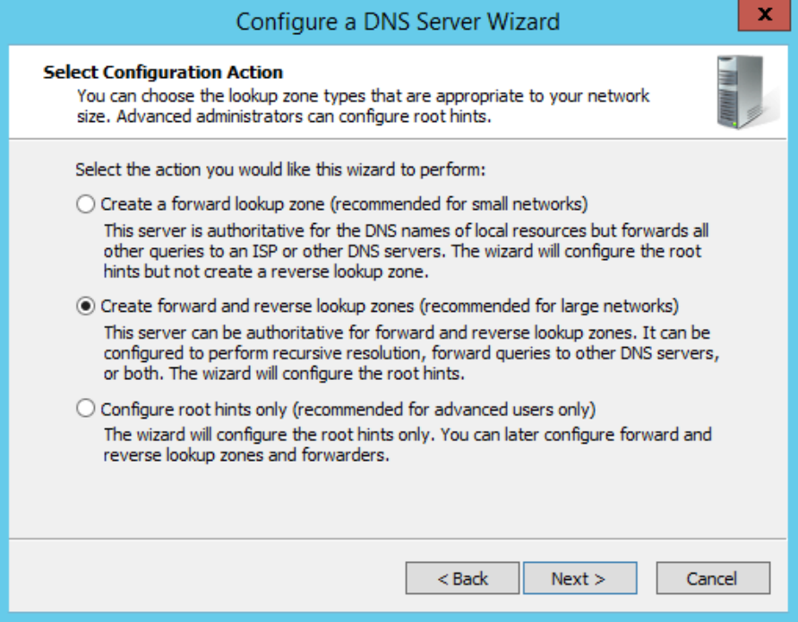
    * Click Next until you get to Zone Name prompt. Enter a zone name and click Next.  
      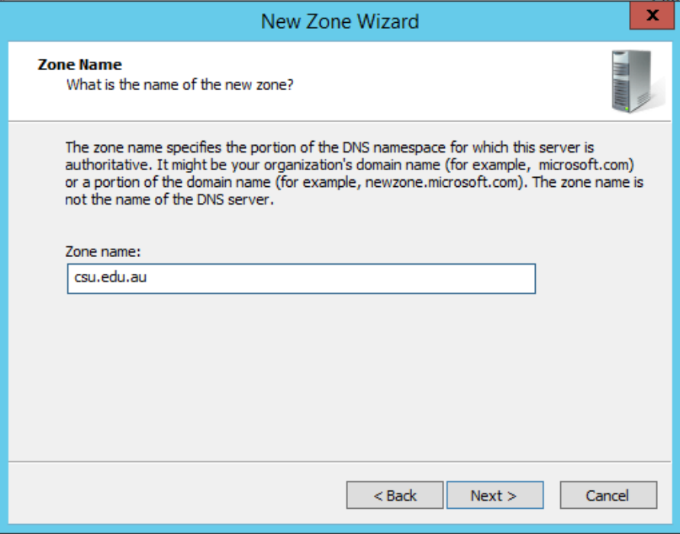
    * Hit next until you reach Dynamic Update. Choose “Allow both nonsecure and secure dynamic updates” and click Next.   
      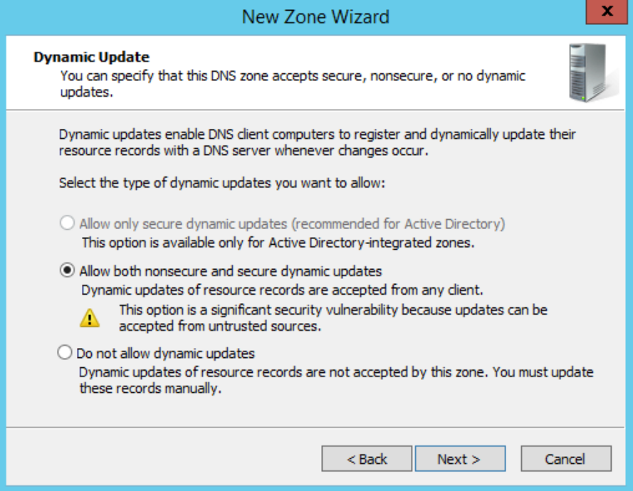
    * Keep clicking Next until you get to the Reverse Lookup Zone Name window. Enter 192 in the network ID section and click Next.  
      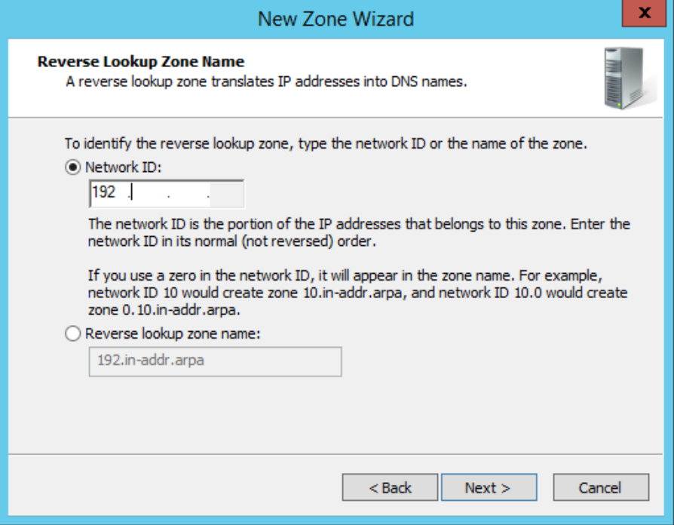
    * Click Next until the Dynamic Update screen, choose “Allow both nonsecure and secure dynamic updates”. Click Next.  
      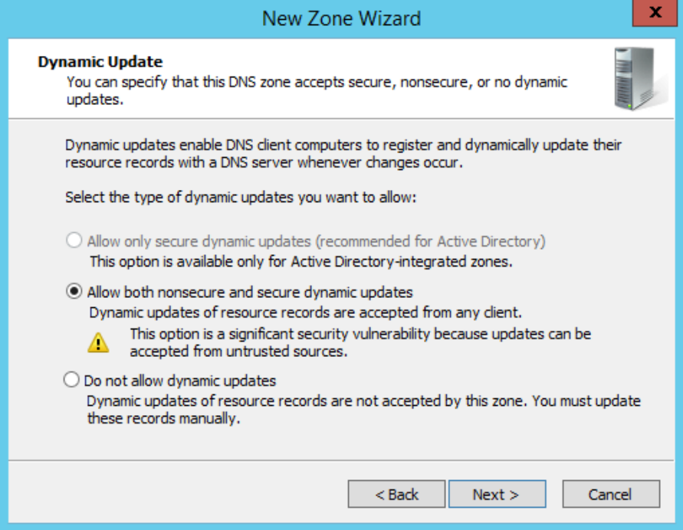
    * Click Finish. There will be a prompt about Root Hints, just click OK.
    * Now we need to add some static DNS entries. Right click on the zone that we just created under Forward Lookup Zones and click on New Host.  
      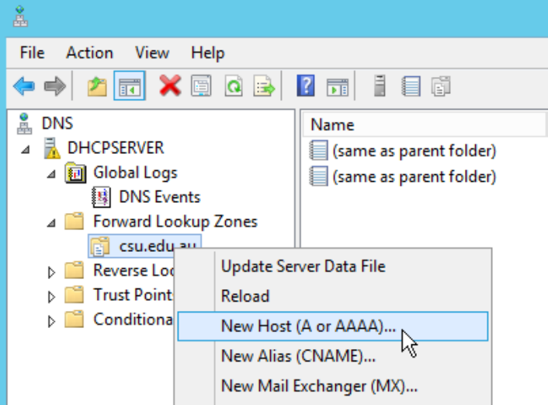
    * Enter the name and IP address for the entry and click Add Host.  
      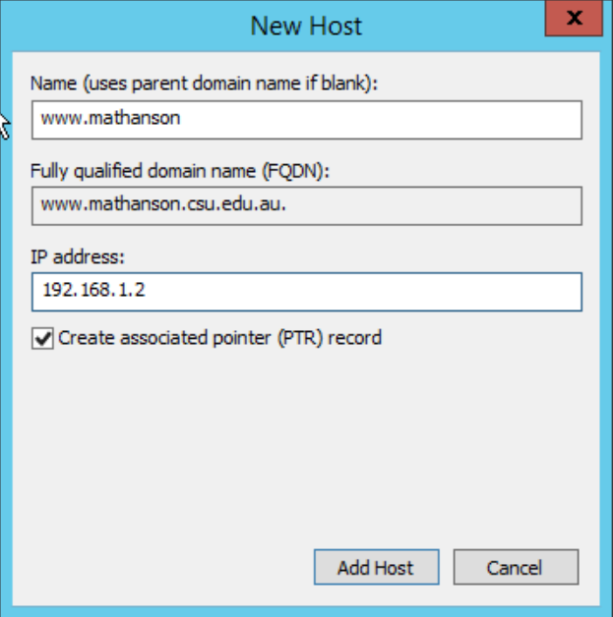
    * Now we just need to test that forward and reverse DNS lookup is functional from a client PC.  
      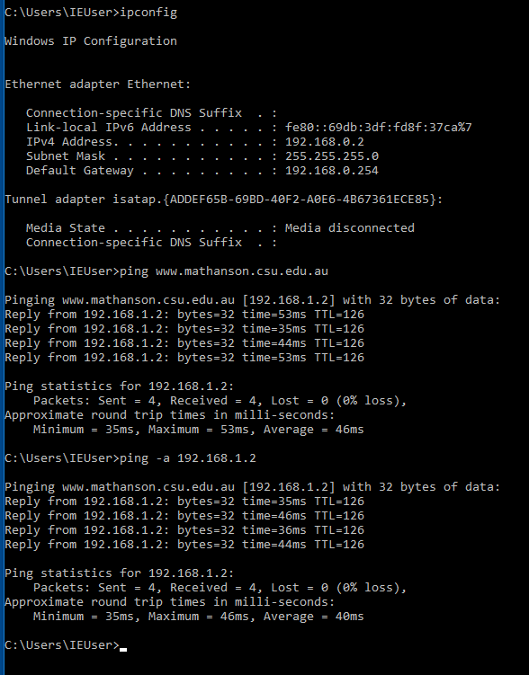
11. **Firewall**I decided to create the firewall using an access control list on fa0/1 of R1 which will block any traffic travelling from 192.168.0.0 to 192.168.1.2 (Web Server).
    * Create the access-list deny entry.  
      
    * Before applying to fa0/1, test connectivity from 2 clients.  
      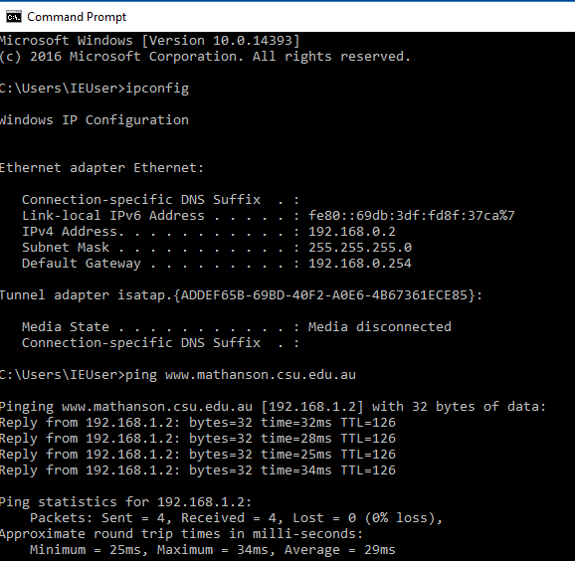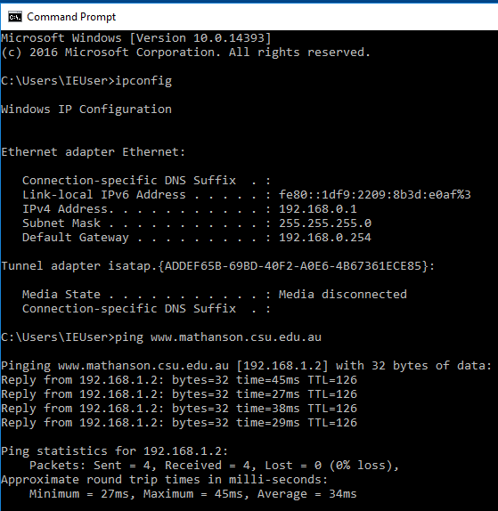
    * Apply the access-list deny entry to fa0/1.  
      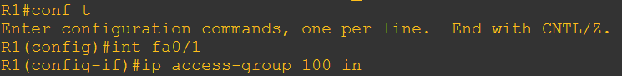
    * Test connectivity from 2 clients. As you can see in the screenshots, the “unreachable” reply is from 192.16.0.254 (R1), which means that the firewall was successfully configured.  
      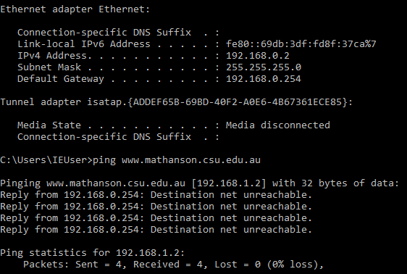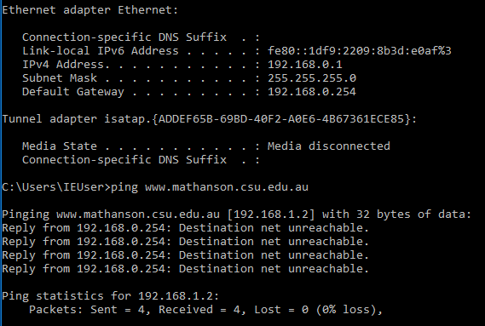
    * I then use the following commands to remove the access-list deny.  
      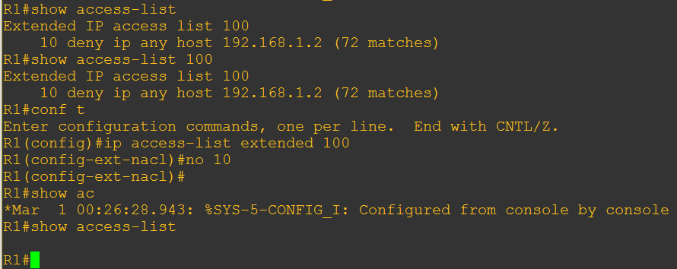
    * Test connectivity from 2 clients. The ping packets are now able to reach the address, meaning that the firewall is no longer in effect.  
      